Metropolitan State University, Saint Paul, Minnesota

ICS 140 Computational Thinking with Programming

Assignment 4

**Areas of Rectangles**

The area of a rectangle is the rectangle’s length times its width. Write a program that asks for the length and width of two rectangles. The program should tell the user which rectangle has the greater area or if the areas are the same.

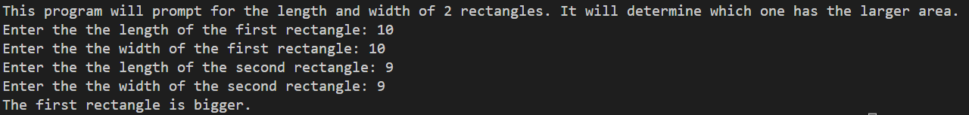

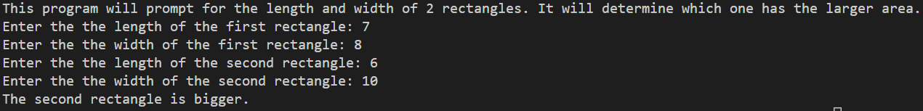

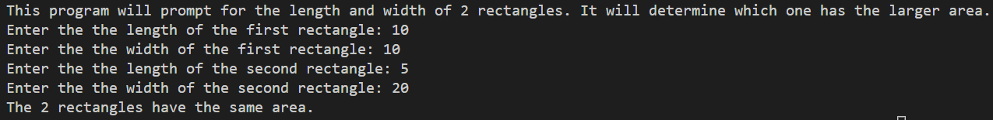

Paste the python code below in the Python code section.

**Assignment 4 Python Code**

*# Prompt user for rectangle area inputs*

lengthOne = int(input("Please enter a length for the first rectangle : "))

widthOne = int(input("Please enter enter a width for the first rectangle : "))

lengthTwo = int(input("Please enter a length for the second rectangle : "))

widthTwo = int(input("Please enter enter a width for the second rectangle : "))

*# Calculate the two areas*

areaOne = lengthOne * widthOne

areaTwo = lengthTwo * widthTwo

*# Output appropriate response*

*if* areaOne > areaTwo:

print("The first rectangle is larger")

*elif* areaOne < areaTwo:

print("The second rectangle is larger")

*elif* areaOne == areaTwo:

print("The two rectangles have teh same size!")

*else*:

print("Error!")

**Test Results**

Show an example of each of the 3 possible results below.

